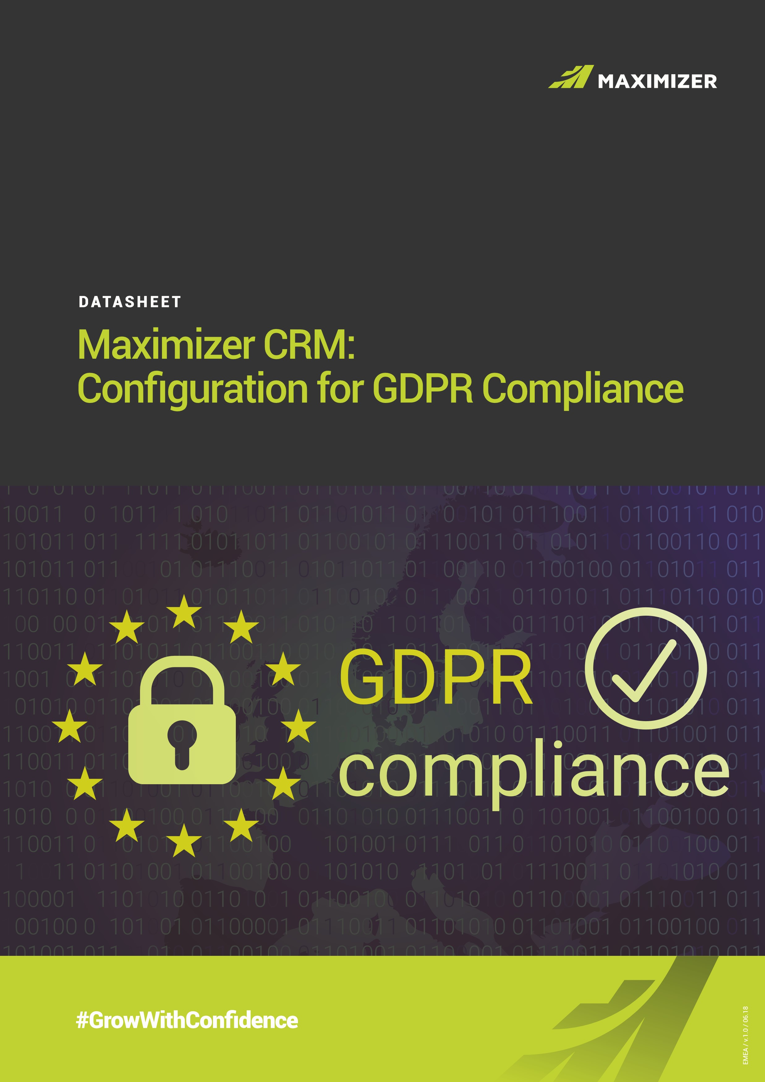

# MAXIMIZER CRM: CONFIGURATION FOR GDPR COMPLIANCE

The EU General Data Protection Regulation (GDPR) in force from 25

May 2018, standardises data protection regulation across the European

Economic Area.

It is designed to govern how organisations treat personal information, putting individuals firmly in control of the way their data is used. The key drivers of the GDPR are privacy, security, accuracy and accountability, which must be embedded into every aspect of your business. This requires businesses to review their ongoing data management practices and systems.

CRM plays a vital role in helping businesses manage their customer data, business processes and activities, and can operate as a significant tool in managing GDPR compliance.

This document provides guidance and a suggested approach to customise and set up Maximizer CRM to fulfil this requirement. It is by no means the only approach but does provide a comprehensive set of data fields to cover the main requirements of the regulations.

N.B. Please note this guidance is based on the latest version of Maximizer CRM Live (older versions and On-premise versions may not have all options available.

# 

# GDPR AT GLANCE

Our recommendation is to either create a separate GDPR Key Field List at Contact and Individual level, or to add a GDPR section as part of an existing Key Field List that tracks Contact and Individual specific information.

The fields shown below are given as suggestions only. The types of fields you add, and the information you hold, will depend on your business and specific way of working.

Under GDPR, your processes and way of working should be documented and communicated clearly to staff through training.

# CUSTOM VIEW

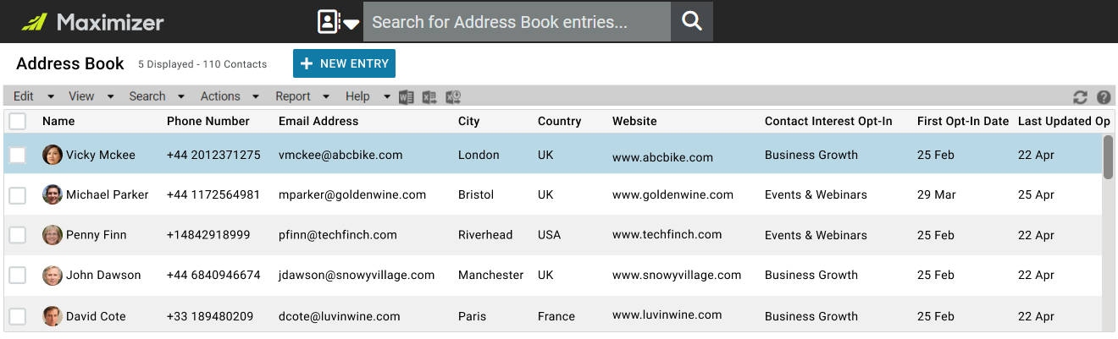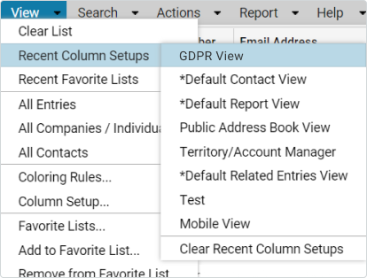

# GENERAL GDPR

Under GDPR, you must have a lawful basis for processing personal data. There are 6 available lawful bases to choose from – which most appropriate basis to use will be dependent on your purpose and relationship with the individual.

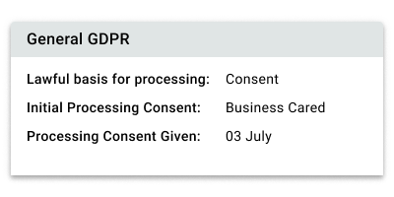

**Lawful Basis for Processing:**

Multi-selection List Field

* Consent
* Contract
* Legitimate Interest
* Legal Obligation
* Public Task
* Vital Interest

**N.B.** You will also need to identify the additional lawful basis for processing Special Category or Criminal Conviction data and create custom fields accordingly.

One of the six legal bases for processing personal information on individuals is Consent. This requires positive Opt-in which needs to be recorded. **Processing Consent by:**

Multi-selection Drop Down List

* Form
* Email
* Verbal
* Business Card

**Processing Consent Given:**

Date Field

**COMMUNICATIONS CONSENT**

You may choose to request additional consent for communications via positive opt-in.

The opt-in should be specific to the type of

information that you plan to provide and not a

general catch-all. Whilst opt-in functionality is

provided as standard in our software against each

email address, and used for Campaigns and General

messages, there may also be a need for additional

opt-in fields if a third party product is used.

**Date Last Contacted:**

Date Field - used to indicate

the last time communication was made with a

Contact or Individual

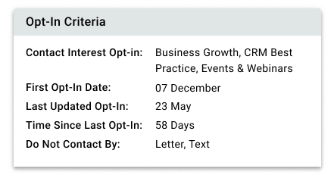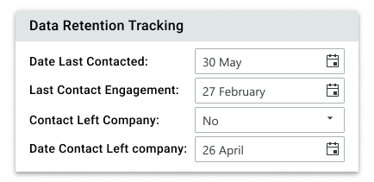

**Contact Interest Opt-In:** Multi-selection Drop Down List -used to track the information a contact or individual is interested in receiving. For example:

* No Consent Given
* Company & Products
* CRM Best Practice • Business Growth
* Events & Webinars
* Research & Reports

**First Opt-In Date:** Date Field - used to track the first date that a Contact or Individual opted In.

**Opt-In Last Updated:** Date Field - used to rack the last time a Contact or Individual changed or updated their opt-in preferences.

**Time Since Last Opt-In:** Duration Field - You may decide on a limited time period before going out again for a renewal of opt-in for communication

**Do Not Contact By:** Multi-selection List Field

* Email
* Fax
* Letter
* Phone
* Text

**DATA RETENTION TRACKING**

As a business you need to review your data collection and management processes and then decide appropriate retention times for keeping personal data.

**Last Contact Engagement**: Date Field - used to track the last meaningful engagement with a Contact or Individual

**Contact Left Company:** Yes/No Field - used to identify if a contact no longer works at a client, prospect, partner or supplier.

**Date Contact Left Company:** Date Field - used to track the date a contact moved from the company.

# SUBJECT ACCESS REQUESTS

The GDPR provides certain rights for individuals in relation to their personal data and can request a number of actions in relation to this. In Maximizer CRM, fields can be added to track these requests and the steps taken to comply with the request.

If there are doubts around the identity of the person making the request you can ask for more information. The period for responding to the request begins when you receive the additional information.

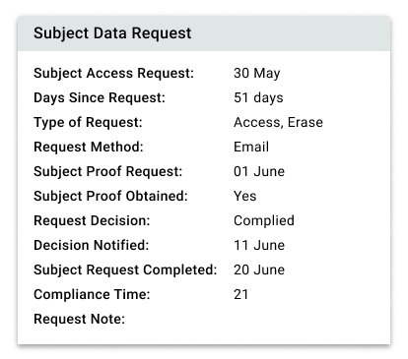

**Subject Access Request:** Date Field

**Days Since Request:** Duration Field - You must act on the subject access request without undue delay and at the latest within one month of receipt. Recommended to adopt a 28-day period to ensure compliance is always within a calendar month.

**Type of Request:** Multi-selection List Field - used to track the type of request a contact or individual has made.

Options could include:

* **Access**: Request to see the information you hold on a person
* **Erase:** Request to be removed from your database
* **Object:** Objection to the information held
* **Portability:** Request for you to share the data you hold with a third party
* **Rectify:** Request to change incorrect information you may hold on a person
* **Restrict/Supress:** Request for you to restrict who has access to a person’s personal data

**Request Method:** List Field

* Email
* Verbal
* Verbal - Telephone
* Website

**Subject Proof Requested:** Date Field

**Subject Proof Obtained:** Yes/No Field - used to track that verification of the contact or individual identity has been undertaken.

**Request Decision:** List Field - Complied/Declined

**Decision Notified:** Date Field

**Subject Request Completed:** Date field

**Compliance Time:** Duration Field – used for reporting on compliance

**Request Note:** Alphanumeric Field - used to track any additional comments or information.

# DATA BREACHES

The GDPR introduces a duty on all organisations to report certain types of personal data breach to the relevant supervisory authority. You must do this within 72 hours of becoming aware of the breach, where feasible.

If the breach is likely to result in a high risk of adversely affecting individuals’ rights and freedoms, you must also inform those individuals without undue delay.

You must also keep a record of any personal data breaches, regardless of whether you are required to notify.

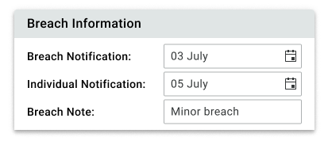

**Breach Notification**: Date Field – date breach experienced or first aware of.

**Individual Notification**: Date Field - used to hold the date the Contact or Individual was advised about a data breach.

**Breach Note**: Alphanumeric Field - used to explain what steps were taken to inform the contact or individual about a breach of their data.

# FURTHER HELP

If you need help in configuring your Maximizer CRM to meet GDPR Compliance please contact our CRM Experts or your Certified Solutions Provider.

More information on GDPR compliance is available on the **ICO website** or the Maximizer GDPR Information Hub.

**CONTACT INFORMATION**

Tel: +44 (0) 1344 766 900

Email: enquiries@maximizer.com

Grow with Confidence

Grow with Maximizer Personalised CRM

We make enabling your success our top priority. That’s why we’re committed to helping each of our customers achieve outstanding results.

With top-rated tools for contact management, lead management and customer service, Maximizer CRM gives businesses everything they need to grow – all in one place.

Today, Maximizer is a global company with offices in five countries plus an international network of Certified Solution Providers. We constantly innovate to ensure our customers can become more successful.



*Vivek Thomas, President*

“Since 1987, more than

1

million

users

and over

120,000

companies

have trusted us to help boost the

bottom line”



**#GrowWithConfidence**

**AMERICAS ( HEAD OFFICE )**

**Maximizer Services Inc.**

260 -

60 Smithe Street

Vancouver, BC

V6B OP5 Canada

Sales

+1 800 804 6299

Phone

+1 604 601 8000

Email

info@maximizer.com

Website

www.maximizer.com

**EUROPE / MIDDLE EAST / AFRICA**

**Maximizer Software Ltd.**

1

The Courtyard

Eastern Road,

Bracknell, Berkshire

RG12 2XB United Kingdom

Phone

+44 (0)1344 766 900

Email

enquiries@maximizer.com

Website

www.maximizer.com/uk

**AUSTRALIA / NEW ZEALAND**

**Maximizer Software SolutionsPty.**

**Ltd.**

Level1, Suite 14, 32 Delhi Road

North Ryde, New South Wales

2113

Australia

Phone

+61 (0)299 572 011

Email

info.anz@maximizer.com

Website

www.maximizer.com/au

**WWW.MAXIMIZER.COM**

Copyright © 2018 Maximizer Services Inc., Maximizer Software Ltd., Maximizer Software Solutions Pty. Ltd. All rights reserved. Maximizer® CRM is a registered

trademark of Maximizer Software Inc. Maximizer CRM, Maximizer CRM Live, Maximizer Contact Management, and other product names may be trademarks of their

respective holders. This is for information purposes only. MAXIMIZER SOFTWARE INC. MAKES NO WARRANTIES, EXPRESSED OR IMPLIED, IN THIS SUMMARY.

Time and time again, they tell us that our exceptional service sets us apart as a market leader in CRM. And that feedback keeps us focused on making planning, selling and management ever easier – to help our customers get rapid results.