Installing Maximizer CRM 2021 R2

This document is a detailed outline of the installation of Maximizer CRM 2021 R2. There are certain aspects of the installation that are not covered by this document. If you have questions that are not addressed in this document, please contact Maximizer Customer Support with your questions.

# Before you Begin

You will need to prepare the following items:

* Your customer number
* Your product serial number
* Your product license number(s)
* The name of your SQL Server, including instance name (eg. SERVER1\INSTANCE) if any
  + Make sure the server’s security is set for “SQL Server and Windows Authentication mode”
  + You will need the SQL login credentials for sa – or a login that has the same security privileges as sa.
* The name of your IIS server
  + Are you using SSL? If so, do you have a server certificate installed?
  + How do the workstations access Maximizer currently? What URL do they use?

This is the first screen that appears. Click **Next**.

If agree to the terms and conditions outlined in the End-User License Agreement, click **Yes**.

You should have been provided with a Customer Number and a Product Serial Number. Please fill in these fields with the appropriate values.

All the fields marked with “*” are mandatory. You cannot proceed past this screen without populating these fields.

When the fields are populated, click **Next**.

You can separate the Maximizer Server and the Maximizer IIS Components.

If you are installing only the IIS components for Maximizer, select only the bottom-most option.

If you are installing only the file server components for Maximizer, select only the top-most option.

This screen gives you the option to install the new Word Integration add-in. The new add-in is installed as a service that runs in a Linux environment. You need to have an instance of Linux running before installing the add-in.

Select the option that currently suits your installation requirements for *Word Integration* and click **Next**.

**NOTE:**

There is currently no method of installing the Word Integration add-in service after completing the installation of Maximizer. If you don’t already have a Linux instance running and you require the Word Integration add-in, you must stop the installation, set up and configure the Linux environment, then restart the installation of Maximizer.

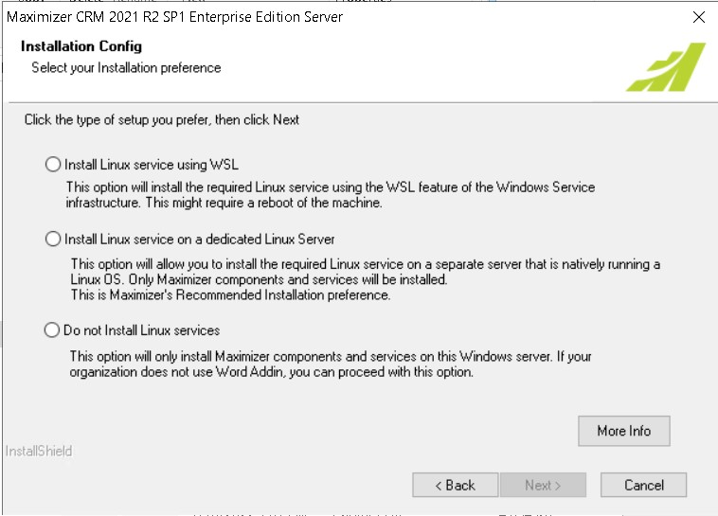

**EXTRA**

If you are installing Maximizer on Windows Server 2019 or later, you will see this screen instead of the previous one. This screen means the Windows Server has the Windows Subsystem for Linux set up and configured.

To install the Word Integration service on WSL, select the top-most option and click **Next**.

If you already have a Linux environment configured and running, enter the IP address/server name of the Linux environment as well as the port number to the redis process.

Click **Next** when complete.

Confirm the location of the Maximizer files and click **Next**.

Confirm the location of the Maximizer shared files and click **Next**.

You have the option to select specific components to install. For complete installation of Maximizer, select *Typical* and click **Next**.

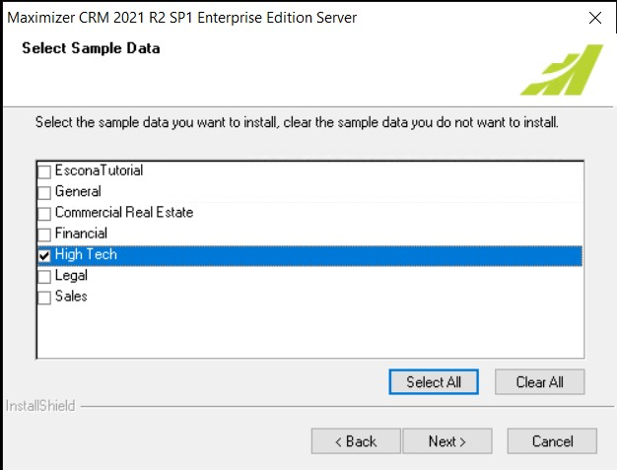

You can choose which sample database to install (or not install any). Click **Next**.

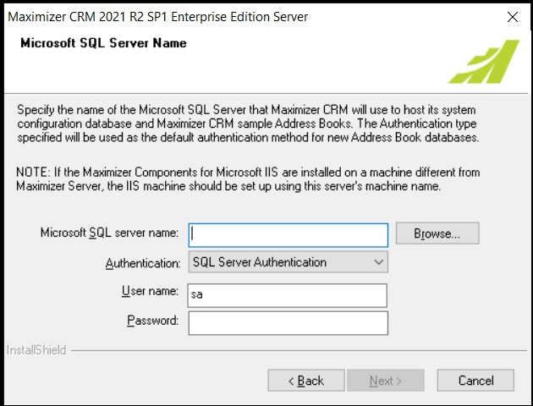

When specifying the SQL Server, make sure you include the instance name, if there is one.

SQL Server Authentication is the only type of authentication to use. Windows Authentication is no longer supported.

Specify the username and password of the SQL login that will give Maximizer full access to install and configure databases and create SQL logins. The sa login is ideally the best one to use. If you do not have the sa user available to you, use a SQL login that has been given the sysadmin server role.

Click **Next**.

**NOTE:**

If you receive a message stating that the MaConfig database already exists on the SQL Server, confirm that you will update it with this installation.

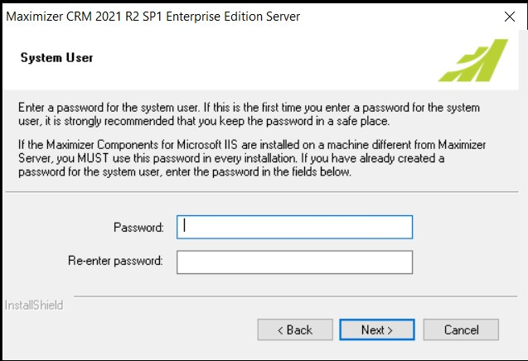

This password corresponds to the Maximizer System User. This password should contain:

* one special character (eg. !,@,$,_)
* one capital letter (ie. A-Z)
* one digit (ie. 1–9)
* be at least 8 characters

Click **Next**.

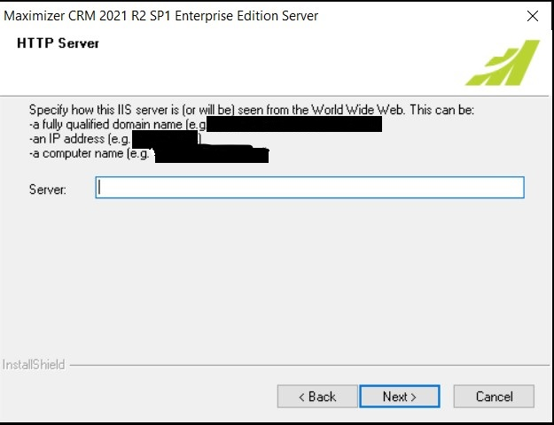

If Maximizer is to be accessible to users external to your office network, you will need to configure your IIS server to properly serve the Maximizer web application.

If Maximizer is reserved for access only to internal office networks, you can use either the server’s computer name or IP address.

Enter the name of the Maximize Web Server and click **Next**.

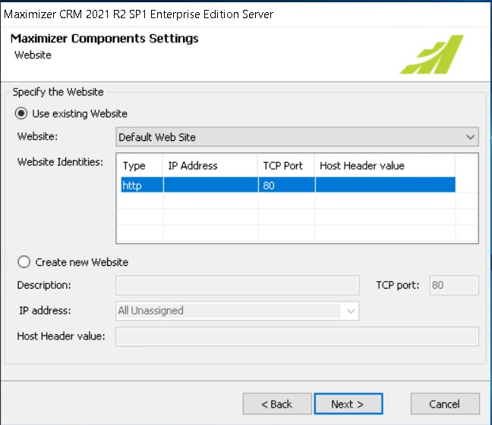

Select the site you wish to install Maximizer into or create a new site for Maximizer. Click **Next**.

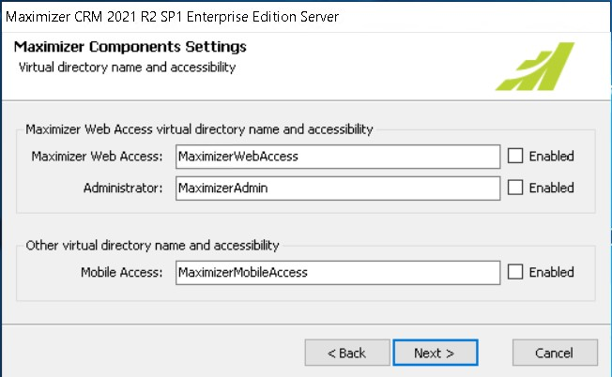

Make sure you enable both Maximizer Web Access and Administrator before proceeding. These 2 directories are essential in having Maximizer ready login after the installation.

**NOTE:**

If you do not see this screen during your installation, you may need to manually enable these 2 directories after the installation is complete.

After enabling the 2 directories, click **Next**.

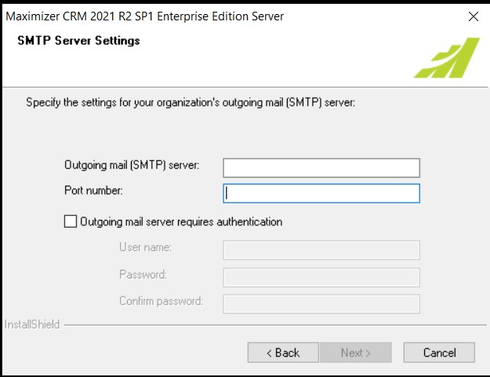

Enter the name or IP address of your SMTP server and its associated port number. If your STMP server requires authentication for access, put a checkmark for the option Outgoing mail server requires authentication.

If you don’t currently have an SMTP server or you wish to configure this later, enter a value into each of the 2 fields.

Click **Next**.

**NOTE:**

You may be prompted with a warning that the STMP server may not exist. Ignore the error and continue with the installation.

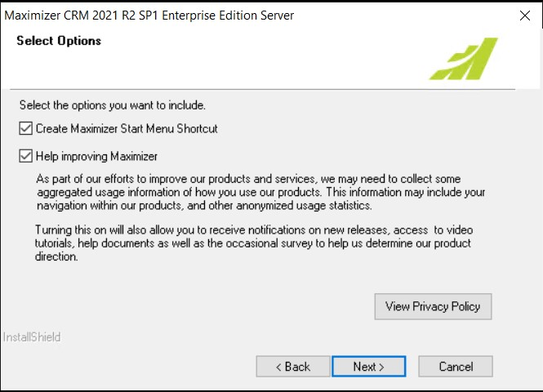

You can leave these options at their current default values or uncheck them. Click **Next**.

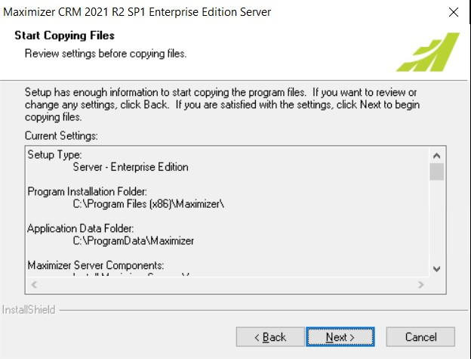

Click **Next**.

The installation will proceed to completion.

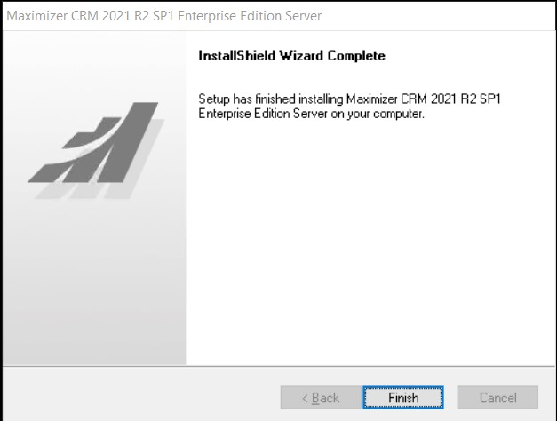

The installation is complete, click Finish.